Specification Planning
Version: | 0.5
Author(s): | MF
Created: | 12/13/2008

Version | Date | Author(s) | Changes
0.1 | 12/13/2008 | MF | Initial version.
0.2 | 12/16/2008 | MF | - design updated  - reviews A replaced by statements  - deadlines adjusted  - notes for deadlines added
0.3 | 12/21/2008 | MF | - conceptual glossary added  - time extension for part B
0.4 | 22/12/2008 | MF | - changed language to English  - added final version for conceptual glossary  - added review for conceptual glossary
0.5 | 23/12/2008 | MF | - translation mistakes corrected

Contents
1. Time Schedule 3
1.1. Deadlines 4
2. Work-Sharing 5
3. Quality Assurance 6
3.1. Statement „infrastructure“ 6
3.2. Statement „project description“ 6
3.3. Review „A“ 6
3.4. Review „system features“ 7
3.5. Review „user interface“ 7
3.6. Review „modeling semantics“ 7
3.7. Review „conceptual glossary“ 7
3.8. Review „final“ 8

Time Schedule

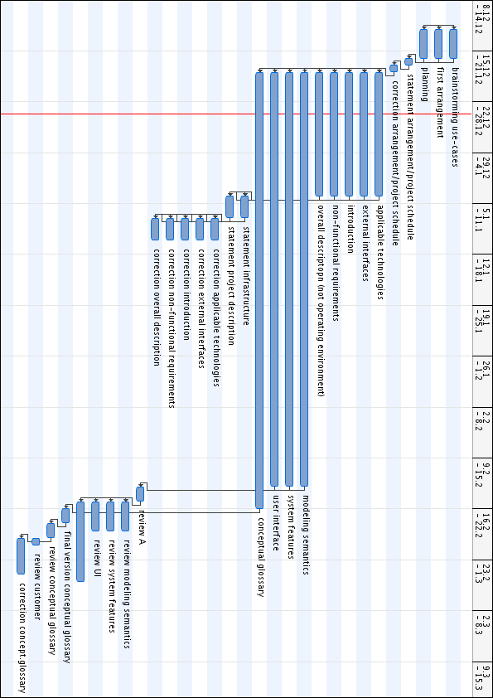

Deadlines
Milestone |  |  | Deadline
DONE | First Arrangement |  | 15.12.2008
CORRECTED | Arrangement |  | 17.12.2008
DONE | Applicable Technologies External Interfaces  Introduction  Overall Description  Non-functional Requirements | A | 03.01.2009
REVIEWED | A (statement) |  | 06.01.2009
CORRECTED: | A |  | 09.01.2009
DONE | System Features  User Interface  Modelling Semantics | B | 13.02.2009
REVIEWED | A |  | 15.02.2009
DONE | Final version conceptual glossary |  | 17.02.2009
REVIEWED | B |  | 19.02.2009
REVIEWED | conceptual glossary |  | 20.02.2009
CORRECTED | B |  | 26.02.2009
CORRECTED | conceptual glossary |  | 26.02.2009

deadline on 15.12.2008 latest delivery on 15.12.2008 23:59.

DONE Creation done
CORRECET Correction done
REVIEWED Review done

Work-Sharing

Brainstorming | Alle (Notizen an Modood, Jonas)
First Arrangement | Markus
Planning | Markus
Statement arrangement | all
Correction arrangement | Markus
Applicable Technologies | Markus
External Interfaces | Markus
Introduction | Daniel
Non-functional Requirements | Daniel
Overall Description | Daniel
Modeling Semantics | Modood, Jonas + Rest (ab 10.1.2009)
System Features | Modood, Jonas + Rest (ab 10.1.2009)
User Interface | Modood, Jonas + Rest (ab 10.1.2009) + Jeoffrey?
Conceptual glossary | all
Final version conceptual glossary | Daniel, Modood

Due to the fact that Markus is responsible for the infrastructure, he’ll adopts the parts Applicable Technologies and External Interfaces. Furthermore he’ll adopt the part Operating Environment in the task Overall Description.

To assure a preferably balanced division, Daniel adopts the parts Introduction, Non-functional Requirements and Overall Description.
Jonas and Modood begin with the tasks System Features, User Interface and Modeling Semantics. If possible, Jeoffrey will support them in the task User Interface.
The conceptual glossary will be created and modified by all team members.
The final version will be made by Daniel and Modood.

As soon as Daniel and Markus finished their parts, they will support Jonas and Modood.

Quality Assurance

In order to avoid information loss all reviews will be recorded.

All contents which will be reviewed will be checked before by statement.

In particular this is valid for the parts / Modeling Semantic / System Features / Conceptual Glossary. These contents should be checked regularly by statements. The tutors will be involved to the statements.

Statement „infrastructure“

Test piece: Applicable Technologies, External Interfaces
Date: 04.01.2009 – 06.01.2009

Author: Markus
Moderator: Markus
Reviewer1: all, tutors too
Recorder: Markus

Statement „project description“

Test piece: Introduction, Overall Description, Non-functional Requirements
Date: 04.01.2009 – 06.01.2009

Author: Daniel
Moderator: Daniel
Reviewer: all, tutors too
Recorder: Daniel

Review „A“

Test piece: Applicable Technologies, External Interfaces, Introduction,
Overall Description, Non-functional Requirements
Date: 13.02.2009 – 15.02.2009

Author: not yet known
Moderator: not yet known
Reviewer1: diverse (Prototyp Team)
Reviewer2: diverse (Prototyp Team)
Reviewer3: diverse (Prototyp Team)
Recorder: not yet known

Review „system features“

Test piece: System Features
Date: 15.02.2009 – 19.02.2009

Author: not yet known
Moderator: not yet known
Reviewer1: diverse
Reviewer2: diverse
Reviewer3 diverse
Recorder: not yet known

Review „user interface“

Test piece: User Interface
Date: 15.02.2009 – 19.02.2009

Author: not yet known
Moderator: not yet known
Reviewer1: diverse
Reviewer2: diverse
Reviewer3: diverse
Recorder: not yet known

Review „modeling semantics“

Test piece: Modeling Semantics
Date: 15.02.2009 – 19.02.2009

Author: not yet known
Moderator: not yet known
Reviewer1: diverse
Reviewer2: diverse
Reviewer3: diverse
Recorder: not yet known

Review „conceptual glossary“

Test piece: Conceptual Glossary
Date: 18.02.2009 – 20.02.2009

Author: Jonas
Moderator: Jonas
Reviewer1: diverse
Reviewer2: diverse
Reviewer3: diverse
Recorder: Jonas

Review „final“

The final review will be executed together with the tutors. As method DCI will be used
(Ludewig,Lichter page 274).

Test piece: complete specification
Date: 19.02.2009 – 20.02.2009

Author: delegate team specification
Moderator: Thomas
Customer: Ralph
Reviewer1: Johannes
Reviewer2: Aleksander
Reviewer3: Reinhold
Recorder: Daniel

